How I started learning Sumo:

Installed it on Windows. Defined on cmd:

set SUMO_HOME="C:\Program Files (x86)\DLR\Sumo\"

Read the Tutorial:

http://sumo.dlr.de/wiki/Tutorials/Hello_Sumo

Started a project from scratch

Took from Brenda’s Matlab script:

lane_o = [757.25 645];

lane_f = [767.75 470];

which gives a theta of -86 degrees.

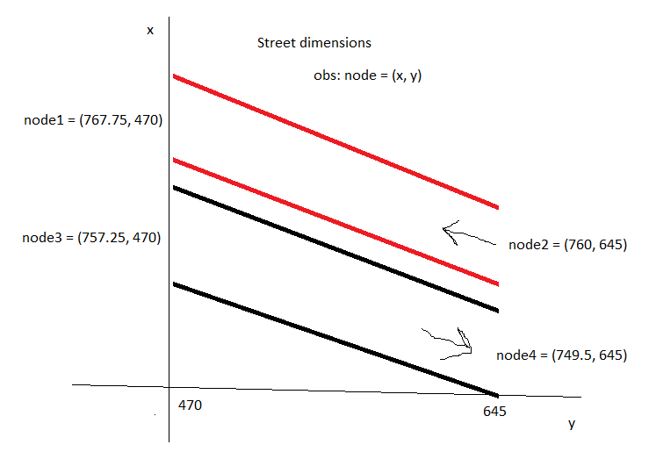

Created node and edge files, and then:

D:\ak\Works\2018-sumo>"C:\Program Files (x86)\DLR\Sumo\bin\netconvert" --node-files=ita.nod.xml --edge-files=ita.edg.xml --output-file=ita.net.xml

Which said: Success.

If I read it using the Sumo’s net editor gives:

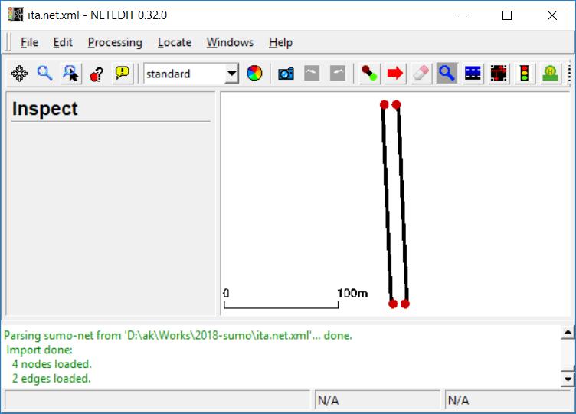

When using the GUI I had to add a delay of 70 ms otherwise the cars would pass too fast and I could not see them (they are the two small yellow points below)

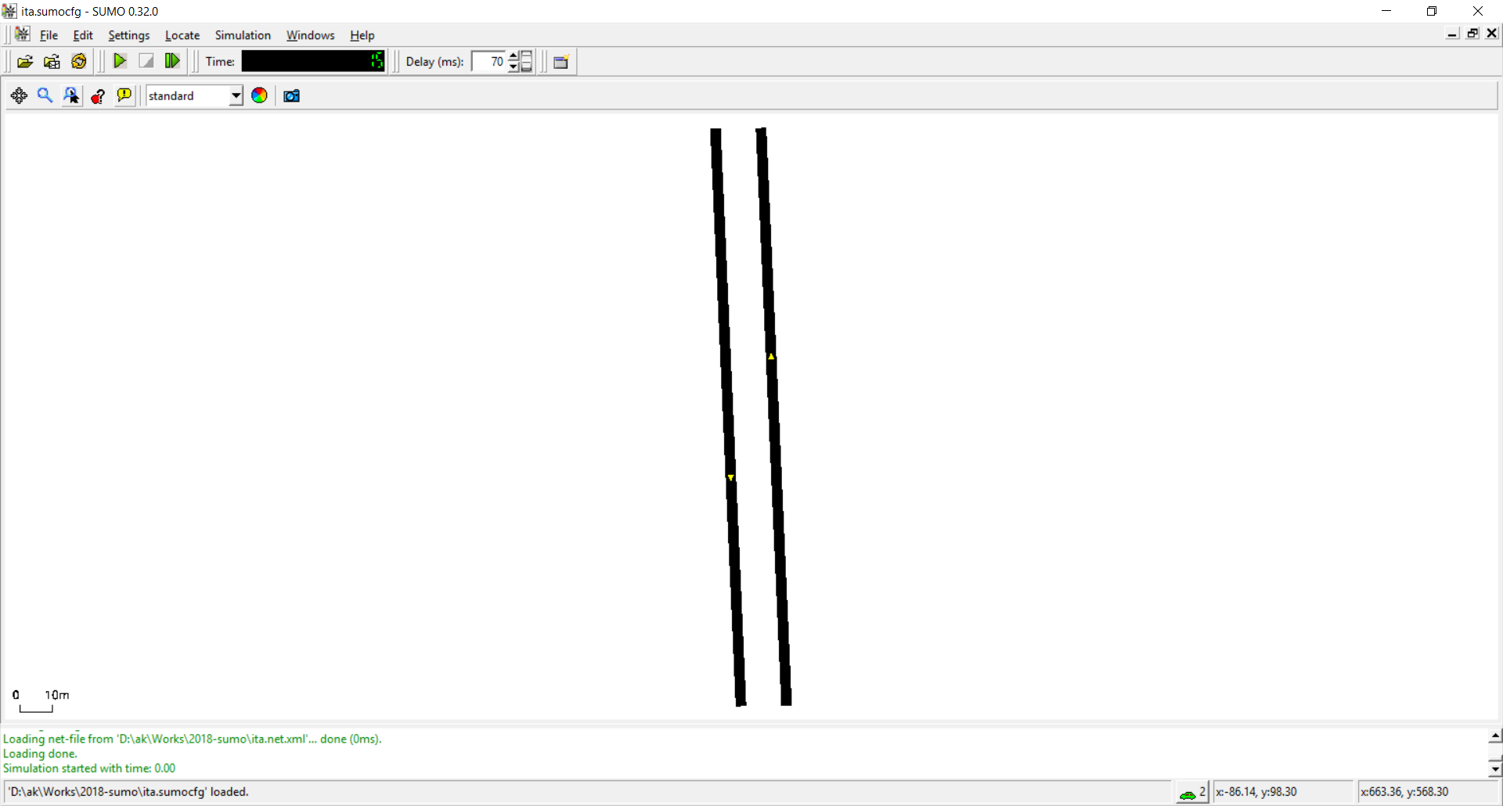

Now started defining other types of cars: <http://sumo.dlr.de/wiki/Definition_of_Vehicles,_Vehicle_Types,_and_Routes>

It is important to study the “Speed Distributions”:

**Caution:**  
Using speed distributions is highly advisable to achieve realistic car following behaviour.

I decreases the sampling interval from 1 to 0.5 using –steplength:

D:\ak\Works\2018-sumo>"C:\Program Files (x86)\DLR\Sumo\bin\sumo.exe" -c ita.sumocfg --fcd-output ak.txt --step-length 0.5

I am not going to read it, but can define the distribution of vehicle types using <http://sumo.dlr.de/wiki/Definition_of_Vehicles,_Vehicle_Types,_and_Routes#Route_and_vehicle_type_distributions>. Maybe more than we need is the Python tool below:

**Note:**  
The python tool [createVehTypeDistributions.py](http://sumo.dlr.de/wiki/Tools/Misc#createVehTypeDistributions.py) can be used to generate large distributions that vary multiple *vType* parameters independently of each other.

I guess we need to use such scripts to simulate jam, putting several vehicles in the street.

I will try to use the following to control how many cars are in the lane. When I use probability=1 there are several (around 7) cars while probability close to 0 leads to few.

But it is not easy to generate a jam, very congested scenario:

<http://sumo.dlr.de/wiki/FAQ#How_do_I_get_high_flows.2Fvehicle_densities.3F>

# Flows with a random number of vehicles

Both [DUAROUTER](http://sumo.dlr.de/wiki/DUAROUTER) and [SUMO](http://sumo.dlr.de/wiki/SUMO) support loading of <flow> elements with attribute probability. When this attribute is used (instead of vehsPerHour,number or period), a vehicle will be emitted randomly with the given probability each second. This results in a [binomially distributed](http://en.wikipedia.org/wiki/Binomial_distribution) flow (which approximates a [Poisson Distribution](http://en.wikipedia.org/wiki/Poisson_distribution) for small probabilities. When modeling such a flow on a multi-lane road it is recommended to define a <flow> for each individual lane.

There are many other tricks described in <http://sumo.dlr.de/wiki/TraCI/Vehicle_Value_Retrieval>

To obtain the position of each car, it is possible to use <http://sumo.dlr.de/wiki/Simulation/Output#Introduction>   
fcd output: Floating Car Data includes name, position, angle and type for every vehicle

If we use Python, more information is provided at <http://sumo.dlr.de/wiki/TraCI/Vehicle_Value_Retrieval>

The sampling period can be controlled by doing a simulation with very small sampling period and later throwing away (eliminating) some vehicles using <http://sumo.dlr.de/wiki/Tools/TraceExporter>

Processing Options

Several options allow to fine-tune the processing.

The output file for

D:\ak\Works\2018-sumo>"C:\Program Files (x86)\DLR\Sumo\bin\sumo.exe" -c ita.sumocfg --fcd-output ak.txt --step-length 0.5

Has the positions we need:

<vehicle id="laneADeterministic.28" x="19.69" y="4.70" angle="357.46" type="Car" speed="1.25" pos="4.64" lane="laneA_0" slope="0.00"/>

<vehicle id="typeB.21" x="5.87" y="5.04" angle="177.46" type="Car" speed="14.16" pos="170.06" lane="laneB_0" slope="0.00"/>

<vehicle id="typeB.22" x="4.20" y="42.87" angle="177.46" type="Bus" speed="14.57" pos="132.19" lane="laneB_0" slope="0.00"/>

<vehicle id="typeB.23" x="3.08" y="68.06" angle="177.46" type="Car" speed="12.79" pos="106.98" lane="laneB_0" slope="0.00"/>

<vehicle id="typeB.24" x="2.16" y="89.00" angle="177.46" type="Car" speed="13.88" pos="86.01" lane="laneB_0" slope="0.00"/>

<vehicle id="typeB.25" x="0.83" y="118.90" angle="177.46" type="Car" speed="14.56" pos="56.09" lane="laneB_0" slope="0.00"/>

<vehicle id="typeB.26" x="-0.31" y="144.67" angle="177.46" type="Car" speed="10.55" pos="30.29" lane="laneB_0" slope="0.00"/>

<vehicle id="typeB.27" x="-1.08" y="161.99" angle="177.46" type="Car" speed="5.92" pos="12.95" lane="laneB_0" slope="0.00"/>

<vehicle id="typeB.28" x="-1.43" y="169.94" angle="177.46" type="Truck" speed="0.97" pos="5.00" lane="laneB_0" slope="0.00"/>

</timestep>

<timestep time="58.50">

<vehicle id="laneADeterministic.21" x="12.80" y="160.40" angle="357.46" type="Car" speed="12.22" pos="160.49" la

Obs: I tried to merge below a deterministic and a probabilistic flow to simulate jam, but did not work.

<routes>

<vTypeDistribution id="typedist1">

<vType id="Car" departSpeed="max" accel="2.6" decel="4.5" length="3.91" maxSpeed="30.0" speedDev="0.1" sigma="0.2" minGap="0.3" probability="0.6"/>

<vType id="Truck" accel="2.0" decel="4" length="4.41" maxSpeed="25.0" speedDev="0.1" sigma="0.2" minGap="0.3" probability="0.2"/>

<vType id="Bus" accel="2.0" decel="4" length="5" maxSpeed="20.0" speedDev="0.1" sigma="0.2" minGap="0.3" probability="0.2"/>

</vTypeDistribution>

<flow id="laneAProbabilistic" color="1,0,0" begin="0" end= "3000" probability="0.99" type="typedist1">

<route edges="laneA"/>

</flow>

<flow id="laneADeterministic" color="0,0,1" begin="0" end= "3000" vehsPerHour="2000000" type="typedist1">

<route edges="laneA"/>

</flow>

<flow id="typeB" color="0,1,0" begin="0" end= "3000" probability="0.95" type="typedist1">

<route edges="laneB"/>

</flow>

</routes>